Theory Exam 08 Answer Script

Question No. 01
Question: Make a function named make_sum() which will take two floating values as parameters and return their sum
Answer: #include<stdio.h>

float make_sum(float x, float y){
float total=x+y;

return total;
}
int main()
{

float a,b;

scanf("%f",&a);
scanf("%f",&b);

float sum=make_sum(a,b);

printf("%f",sum);
}

Output

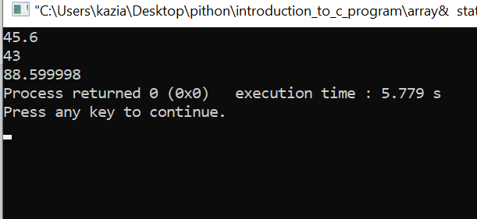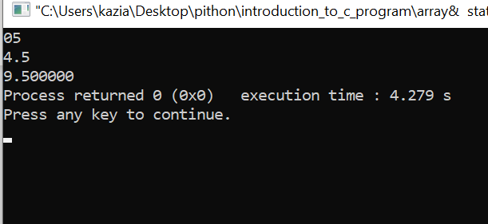

Question No. 02
- Question: Make a function named make_average() which will take an array of integers and the size of that array and return the average of those values.

Answer: #include<stdio.h>
float make_average(int ar[], int n)
{
int count=0;
for(int i=0; i<n; i++)
{
count+=ar[i];
}
float average = (float)count/n;
return average;
}
int main()
{
int n;
scanf("%d",&n);

int ar[n];

for(int i=0; i<n; i++)
{

scanf("%d",&ar[i]);
}

float average1=make_average(ar, n);

printf("avarage=%.2f ",average1);
}

Output

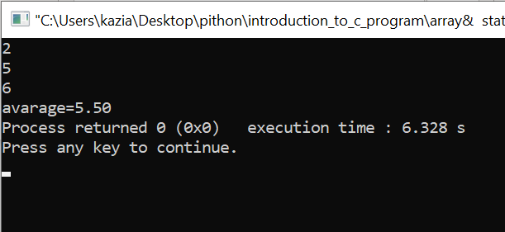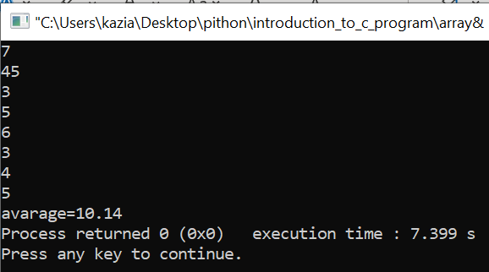

Question No. 03
- Question: Make a function named count_zero() which will take a binary string (Binary string is a string which is consist of only 0 and 1) as parameter and count how many 0’s are there in that string

Answer: #include<stdio.h>
int count=0;

int count_zero(char *a){
for(int i=0; i<strlen(a); i++){
int val=a[i];
if (val=='0'){
count++;
}
}
return count;
}

int main()
{

char ar[100];

scanf("%s",ar);

int count1=count_zero(ar);
printf("%d",count1);
}

Output

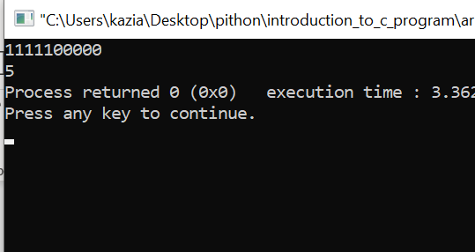

Question No. 04
- Question: Make a function named foo() which prints “foo\n” and a function named bar() which prints “bar\n”. Call function foo() in the main() function and call function bar() in the foo() function after printing. What will be the output?

Answer: #include<stdio.h>

void foo(){
printf("foo\n");
bar();
}

void bar()
{

printf("bar\n");

}
int main()
{

foo() ;

}

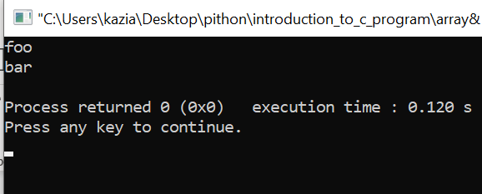

Question No. 05
- Question: Make a function named check_array() which will take an array of integers and the size of that array N. It will return a boolean type whether this array has all values from 1 to N or not.

Answer: #include<stdio.h>
#include<stdbool.h>
int ar3[100]={0};
bool check_array(int *a, int n)
{
bool arr=true;
for(int val=1; val<=n; val++){
printf("\n%d %d ",val,a[val]);
}
for(int val=1; val<=n; val++){

if(a[val]<=0){
arr=false;
return arr;
}
}
return arr;

}

int main()

{

int n,j=0;
printf("Enter arry size:");
scanf("%d",&n);
int ar[n], ar2[n];
int a=n;
for(int i=1; i<=n; i++){
printf("Enter arry element %d:",a);

scanf("%d",&ar[i]);
a--;
}

for(int i=0; i<=n; i++){
ar2[i]=i;

}

for(int i=1; i<=n; i++){
int val=ar[i];
ar3[val]++;
}
bool xx=check_array(ar3,n);

if(xx==1){
printf("\nTrue");
}
if(xx==0){
printf("\nFalse");
}
}

Question No. 06
Question:
Make a pointer variable P which points to an integer variable. Make another pointer variable Q which points to the pointer P. Now make another pointer variable R which points to the pointer Q. Now change the value of that integer variable by accessing pointer R.

Answer: #include<stdio.h>
int main()
{

int value=9,*p,**Q,***R;
p=&value;

Q=&p;
R=&Q;

***R=5; //changeing the value

printf("%d",value);
}

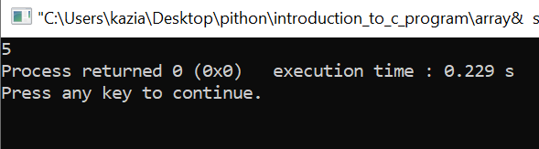

Question No. 07
Question:. Make a function named count_swaps() which will take an array of integers and the size of that array. You need to tell how many swaps you need while implementing the selection sort that is shown in the module video and return that number of swaps from that function
Answer:
#include<stdio.h>
int count=0;
int count_swaps(int *a ,int n)
{
for( int i=0; i<n-1; i++){
for(int j=i+1; j<n; j++)
{

if(a[i]>a[j]){
int temp=a[i];
a[i]=a[j];
a[j]=temp;
count ++;
}
}
}
return count;

}

int main()
{

int ar[4]={4,3,2,1};

int xx=count_swaps(ar ,4);
for(int i=0; i<4; i++){
printf("%d ",ar[i]);
}

printf("\nnumber of swaps : %d ",count);

}

Question No. 08
- Question: Make a function named odd_even() which takes an integer value and tells whether this value is even or odd. You need to do it in 4 ways:
i) Has return + Has parameter
ii) No return + Has parameter
iii) Has return + No parameter
iv) No return + No parameter

Answer:
i) Has return + Has parameter

#include<stdio.h>
int odd_even(int v){

if(v%2==0){
return 2;
}
else
{

return 1;
}
}
int main()
{
int value;

scanf("%d",&value);

int va=odd_even(value);

if(va==2){
printf("even");
}
else
{
printf("odd");
}
}

ii) No return + Has parameter

#include<stdio.h>
int odd_even(int v){
if(v%2==0){
printf("even");
}
else
{
printf("odd");
}
}
int main()
{
int value;

scanf("%d",&value);

odd_even(value);
}

iii) Has return + No parameter

#include<stdio.h>
int odd_even(){

int value;

scanf("%d",&value);
if(value%2==0){
return 2;
}
else
{

return 1;
}

}
int main()
{

int val=odd_even();

if(val==2)
{

printf("even");
}

else
{
printf("odd");
}
}

iv) No return + No parameter

#include<stdio.h>
int odd_even(){

int value;

scanf("%d",&value);
if(value%2==0){
printf("even");
}
else
{

printf("odd");
}

}
int main()
{

odd_even();

}

Question No. 09
You know palindromes, right? Now make a function named check_palindrome() which will take a string as a parameter and return the minimum number of characters you need to change so that the string can become palindrome. You can’t add or delete any character.

Answer: #include<stdio.h>
char a[100],ar[100],ar2[100];
int j=0,m=0,count=0;

int check_palindrome(char *arr)
{

for(int i=0; i<strlen(arr); i++)
{
ar[j]=arr[i];
j++;
}
int l=strlen(arr);

for(int i=l-1; i>=0; i--)
{
ar2[m]=arr[i];
m++;
}

printf("\nTo make palindrome minimum number char need to change\n");
for(int i=0; i<strlen(arr); i++)
{
if(ar[i]!=ar2[i]){
count++;
}

}

return count/2;

}
int main()
{

scanf("%s",&a);

int xx= check_palindrome(a);

printf("\n%d",xx);
}

Question No. 10
Question: Make a function named change_array() which will take an integer array and size of that array. After that you will reverse that array and put that in a new array and print it in the main() function. You know that you can’t return an array normally, so you need to make that array in the main() function and pass that through the parameter.

Answer:
#include<stdio.h>
int ar2[ ];
int change_array(int*a, int n){
int j=0;
for(int i=n-1; i>=0; i--) {

ar2[j]=a[i];
j++;
}
}

int main()
{

int n, j=0;
scanf("%d",&n);
int ar[n];

for(int i=0; i<n; i++) {

scanf("%d",&ar[i]);
}

change_array(ar,n);

for(int i=0; i<n; i++) {

printf("%d ",ar2[i]);
}
}

